WCMICS Grants Program

Scale & Spread Funding Stream

Guidelines 2021/22

Authorship

Key contact: Dilu Rupassara
Services Development Manager
dilu.rupassara@petermac.org

Reviewed by: Kath Quade
WCMICS Manager
kathy.quade@petermac.org

Michael Barton
Quality & Performance Manager
Michael.barton@petermac.org

Contents

Scale & Spread Funding Stream 1
Guidelines 2021/22 1
1 Funding Guidelines 2021/22 4
1.1 Background 4
1.2 Grants Program Funding Streams 4
1.3 VICS Implementation Plan 2021-22 4
1.4 Scaling-up Framework 6
1.5 Funding Availability 7
1.6 Application Process & Project Evaluation 7
2 Funding Timetable 10
2.1 Timetable for Application Process 10
3 Selection Criteria for WCMICS Grants Program Scale & Spread funding stream 2021/22 11
3.1 General Inclusion Criteria 11
3.2 General Exclusion Criteria 11
4 Conditions of Funding & Reporting Requirements 12
4.1 Funds Release Notification 12
4.2 Further Information 12
5 Key Resources 13
Appendix 1: 14
Elements that make a successful WCMICS-funded project 14
Appendix 2: 15
Expression of Interest template 15

Funding Guidelines 2021/22

Background
The Western & Central Melbourne Integrated Cancer Service (WCMICS) is funded by the Victorian Department of Health (DH) and is part of the Victorian Integrated Cancer Services (VICS) network, which is composed of three metropolitan and five regional Integrated Cancer Services (ICS), plus one state-wide paediatric ICS. We build relationships between healthcare providers and other cancer care stakeholders to develop, implement and evaluate initiatives that improve the way Victoria’s health services provide care and support.
The ICS activity supports the achievement of three of the five goals stated in the Victorian cancer plan, namely that:
- Victorians know their risk and have cancers detected earlier;
- Victorians with cancer have timely access to optimal treatment; and
- Victorians with cancer and their families live well​
WCMICS works through seven constituent public health services:
- Melbourne Health | - Royal Women's Hospital
- Peter MacCallum Cancer Centre | - St Vincent's Hospital Melbourne
- Royal Victorian Eye and Ear Hospital | - Werribee Mercy Hospital
- Western Health (including Djerriwarrh Health Services)

The principal aim of the WCMICS Grants Program is to provide seed funding for quality improvement and/or service redesign projects undertaken at our member health services that will improve cancer patient outcomes and/or experiences. The program encourages effective partnerships and collaboration between other cancer care service providers and consumers; to improve coordination, accessibility and quality of care provided to better support all people affected by cancer. WCMICS assists with facilitating this collaboration through its network of health service contacts.

Grants Program Funding Streams
WCMICS runs 2 separate funding initiatives:
- Innovate & Improve (offered annually)
- Scale & Spread (offered biennially)

The Innovate & Improve funding stream is open to all initiatives that are new, innovative improvement ideas.

The Scale & Spread funding stream is open to initiatives that intend to make deliberate efforts to increase the impact of successfully tested health innovations so as to benefit more people.

VICS Implementation Plan 2021-22
The VICS Implementation Plan summarises how, over the next two years, VICS will work towards addressing its roles and responsibilities in the Victorian Cancer Plan 2020-2024 (VCP). Figure 1 shows the three core priorities of the plan and specific focus areas that sit under those priorities.
Figure 1: VICS 2021-22 Priorities

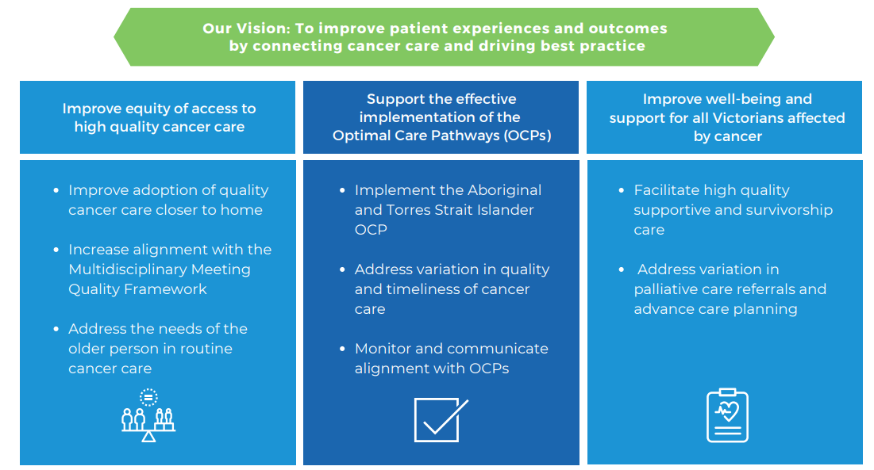

The following specific areas of the above priorities have been identified as the focus of the WCMICS Grants Program Scale & Spread funding stream 2021/22.
Priority Area | Justification
Supporting Aboriginal and Torres Strait Islander people affected by cancer to improve access to timely cancer care. | Aboriginal Victorians have significantly higher cancer incidence (+77%) and mortality rates (+139%) compared with other Victorians. There are various complex reasons for this across the care pathway. Although the WCMICS region does not have a large Aboriginal population compared with other regions, every year WCMICS health services care for a significant number of people who identify as Aboriginal.  [Source: Victorian Cancer Registry 2019, ABS Census 2016]
Supporting newly diagnosed cancer patients to optimise their health prior to acute treatments. | The optimisation of pre-treatment health status, also known as prehabilitation or prehab, is a multidisciplinary approach combining exercise, nutrition and psychological strategies to prepare patients for the challenges of cancer treatment. The optimal care pathways recommend prehab, stating that “Evidence indicates that patients who respond well to prehabilitation may have fewer complications after treatment.” Current access to prehab services varies between health services and tumour streams. Therefore this priority area aligns with all three of the overarching core priorities of the VICS Implementation Plan.  [Source: Optimal Care Pathways 2021, Victorian Tumour Summits 2019]

The program will provide funding for tested, evidenced-based scalable initiatives which address one of the above priority areas. Applicants will need to explain how their project aligns with the priority area.

Scaling-up Framework

‘Scale up’ is defined by the World Health Organization (WHO) as, ‘the deliberate effort to increase the impact of successfully tested health interventions so as to benefit more people and to foster policy and program development on a lasting basis’¹. WHO collaborated with ExpandNet, an informal network of global health and development professionals who seek to advance the science and practice of scale up, to develop a scale-up framework (see figure 3 below).

Applicants are encouraged to consider the framework and familiarise themselves with the terminology used, which is mirrored in the expression of interest (EOI) template.

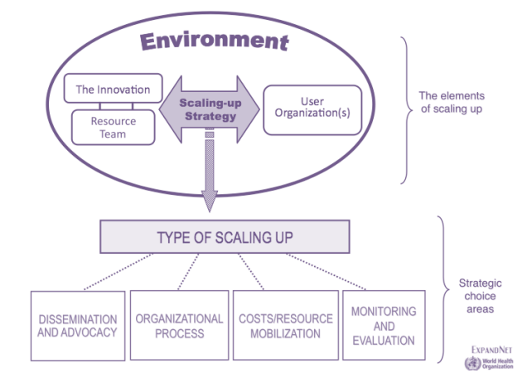
Figure 3. Scaling-up framework

The framework includes five interacting elements of scaling up:

The innovation - The package of interventions or other new practices being scaled up. While changes to the innovation may be made from pilot to scale-up, the essential elements must remain constant, as they are key to the innovation’s effectiveness.

Resource team refers to the individuals and/or organisations who facilitate the scale-up of the innovation – they take the active steps to move the scale-up process along. E.g. Project staff, clinical lead, executive sponsor, VICS staff.

User organisations refers to the organisations who are required for a successful implementation of the innovation on a large scale. Alongside the resource team their input is essential to development of the scaling –up strategy. E.g. Partner health services, NGOs, community health organisations, consumer groups.

Environment refers to conditions or institutions outside of the user organisation that can influence the scale-up process. Taking the time to understand the unique context in which the innovation is being implemented allows implementers to make modifications to the innovation, or to the scaling-up strategy.

Scaling-up strategy - Must be developed based on the analysis of the above four elements. The strategy includes plans for how to implement the innovation at multiple levels (policy, program, and service delivery), considerations for how to advocate for the innovation, the organisational processes involved in implementation and the costs and resources needed.

The two main types of scaling-up strategy are:
- Vertical scale-up (Simultaneous approach)
Scaling up using a vertical approach involves the introduction of an intervention simultaneously across a whole system and results in institutionalisation of a change through policy, regulation, financing, or health systems change.
- Horizontal scale-up (Stepwise approach)
Scaling up using a horizontal approach involves the introduction of an intervention across different sites or groups in a phased manner, often beginning with a pilot program, followed by stepwise expansion, learning lessons along the way to help refine further expansion.

Funding Availability

Applications for funds are open to a lead member health service with identified partnerships / multi-site engagement to support the deliberate effort to increase the impact of successfully tested health innovations to the benefit of more people affected by cancer. Applications must address the criteria, as set out in these guidelines, to be eligible for funding.

Applications can request up to a maximum of $400,000 per project, spread across a maximum project period of 30 months. Payments will be made on commencement of the project and at yearly milestones, subject to deliverables being achieved.

Application Process & Project Evaluation
The WCMICS Grants Program application process involves two stages:
- Stage one: Initial Expression of Interest (EOI) and the opportunity to 'idea pitch' to the funding evaluation panel.
- Stage two: Following panel review, project plan development is by invitation only.

EOIs should be completed using the attached EOI template. All EOIs must be submitted to WCMICS via the health service’s nominated representatives as listed in Table 1 below. There is no limit on the number of EOIs that a health service can submit but health services are required to rank their submitted EOIs in order of alignment with local organisational priorities. This ranking will be used by WCMICS to shortlist EOIs in the event that there is not capacity to evaluate all EOIs at the project pitch session.

Health Service | Nominated representatives
 | Clinical / operations lead | Executive lead
Melbourne Health | Kristie Mackenzie – Director Nursing and Operations Manager, Medical Services  Kristie.Mackenzie@mh.org.au | 0413 563 593 | A/Professor Kirsty Buising – Medical Director, Medical Services  Kirsty.buising@mh.org.au
Peter MacCallum Cancer Centre | A/Prof Kate Burbury - Consultant Haematologist, Director, Digital and Healthcare Innovations  kate.burbury@petermac.org | 03 8559 8425 | Geraldine McDonald - Director of Prevention and Wellbeing  Geraldine.McDonald@petermac.org | 03 8559 6265
Royal Victorian Eye & Ear Hospital | Fiona Moran - Acting Director Ambulatory Services  fiona.moran@eyeandear.org.au | 03 9929 8068
Royal Women’s Hospital | Dr Mark Garwood - Chief Medical Officer  mark.garwood@thewomens.org.au | Laura Bignell - Executive Director Nursing and Midwifery and Neonatal Director  Laura.Bignell@thewomens.org.au
St Vincent’s Hospital Melbourne | Lesa Stewart - Group Manager Cancer and Palliative Care Services  Lesa.STEWART@svha.org.au | 03 9231 4818 | Nicole Tweddle - Executive Director Acute Services  nicole.tweddle@svha.org.au
Werribee Mercy Hospital | A/Prof Thomas Chan - Acting CMO and Clinical Services Director Medical, Subacute and Palliative Care Services. Thomas.Chan@mercy.com.au | Edward Wallace - Program Director Perioperative and Specialist Services EWallace@mercy.com.au
Western Health  (including Djerriwarrh Health) | Dr Dishan Herath - Director of Cancer Services  Dishan.Herath@mh.org.au | 0417 058 829 | John Ferraro - Deputy Executive Director Operations  john.ferraro@wh.org.au | 03 8345 4095
Table 1: Health Service nominated representatives for WCMICS Grants Program expressions of interest

It is strongly recommended that applicants speak to their local nominated representatives before completing the EOI template to ensure capacity and capability to undertake the project (see Table 1 for contact details). WCMICS staff are also available to discuss project ideas and applicants are encouraged to get in contact before they finalise their EOI.

To ensure maximum scalability applicants are also encouraged to make contact with potential partner health services and other potential partner organisations before submitting their EOI. WCMICS staff can assist in making these connections if required.

Applications that are submitted by the applicants directly to WCMICS and not through the nominated health service representatives will be deemed ineligible for funding.

All Expressions of Interest for the WCMICS Grants Program Innovation and Improvement stream 2021-22 must be received by the WCMICS Directorate by 5:00pm on 8 April 2022. Please submit applications via email to contactwcmics@petermac.org .

Consumer Input

Engagement of consumers is a core element of the WCMICS Grants Program, with all funded projects encouraged to engage people with experience of cancer across all facets of the project, including on their steering group. The EOI template includes a “Voice of Consumer” section where applicants can describe their consumer engagement.

Evaluation Panel and Project Endorsement

An initial screening of EOIs against the general criteria will be performed by the WCMICS program office. Dependent on the number of EOIs making this initial shortlist, further shortlisting may occur based on the priority ranking provided by the health services. Applicants with shortlisted EOIs will be invited to pitch their projects in front of an evaluation panel in the week beginning 25 April 2022.

The evaluation panel typically involves members (including consumers) of the WCMICS Governance Committee, WCMICS Clinical Management Advisory Committee, WCMICS program leadership and Department of Health representatives. They will evaluate the projects based on impact, project quality and likelihood of success.

The WCMICS Consumer Group review all EOIs and their feedback is represented by consumer members on the evaluation panel.

Shortlisted applicants will be informed by 29 April 2022, and will be invited to progress to stage 2, project plan development. Details of successful project applications will be announced by 30 June 2022.

Funding Timetable

Timetable for Application Process

ACTION | DATE
Call for Expressions of Interest (EOI) | 17 February 2022
EOI close | 8 April 2022
Pitch session with Evaluation Panel | Week beginning 25 April 2022
Shortlisted applicants invited to develop project plans | 29 April 2022
Final project plan submission deadline | 3 June 2022
Letters of agreement signed by CEOs | By 30 June 2022
Successful applicants announced | 30 June 2022
Project commencement | July/August 2022
Project completion | By 31 December 2024

Selection Criteria for WCMICS Grants Program Scale & Spread funding stream 2021/22

All project applications will be evaluated for compliance with the WCMICS Funding Guidelines 2021/22 and screened using the selection criteria outlined below:

General Inclusion Criteria
- The duration of the project must be no longer than 30 months.
- Projects must aim to improve care and/or experience for people affected by cancer through evidence-based initiatives that intend to make deliberate efforts to increase the impact of successfully tested health innovations so as to benefit more people.
- Projects must aim to implement a sustainable improvement in service provision across multiple sites and/or tumour streams.
- EOIs must nominate a WCMICS member health service as the lead organisation and identify other partnerships to be engaged through the project.
- Applicants must demonstrate their capacity, commitment and capability to lead this scaling project and have organisational support to do so.
- Projects must reference the relevant WCMICS priority area being addressed.

General Exclusion Criteria
- Projects that fail to address the general inclusion criteria.
- Recurrent positions or non-sustainable initiatives.
- Projects trialling an unproven intervention.
- The provision of staff to provide direct patient care.
- The provision of staff to provide data entry or data managers.
- Purchasing pieces of equipment for service delivery (NB. requests for funding for the purchase of equipment to support service change will be considered).
- Corporate overhead fees.
- Projects submitted directly to WCMICS by individual applicants (i.e. projects must go through health service prioritisation and be submitted by relevant nominated representative).
- Projects which are inconsistent with the objectives of WCMICS and/or other state-wide initiatives.

Conditions of Funding & Reporting Requirements

Funding will be allocated to successful applicants on the basis that:
- The project has been approved for funding by the evaluation panel as described above with any specific conditions specified by the review panel having been met in the project plan documents.
- The project will be conducted in accordance with the methodology, timelines and allocated budget stated within the final agreed project plan and the conditions stipulated in these guidelines. Any deviation in the project from the original submission must be discussed with and agreed to by the WCMICS program office and documented in a Project Amendment Form supplied by WCMICS.
- Ethics applications (where necessary) are submitted by the Project Lead in line with local health service requirements.
- Quarterly project updates will be provided by the Project Lead and report through to WCMICS Clinical Management Advisory Committee and Governance Committee. Updates will include a brief synopsis of work completed in the previous three months, highlight any achieved objectives, identify risks both new and mitigated, and identify key project deliverables met as appropriate. Quarterly reports will be presented at WCMICS Governance Committee meetings.
- Project Leads be available to participate in WCMICS funded projects Communities of Practice
- An Interim Progress Report and Final Report (including evaluation, sustainability and expenditure report) will be submitted to the WCMICS Directorate at the project mid-point and completion, respectively (templates to be provided by WCMICS).
- Failure to supply project Interim and Final reports may affect future funding applications for that health service.
- Information on the project, including any tools/resources developed, will be made available to the WCMICS Directorate to enable promotion of the Grants Program and information sharing with other organisations.
- WCMICS is to be acknowledged as the funding body in any published documents, or during any presentation of the project outcomes or associated results of process improvements. Failure to acknowledge WCMICS may affect future funding applications.

Funds Release Notification

Project funding will be awarded to successful applicants upon receipt of a signed letter of agreement and made available to the hospital/health service with an initial invoice to be raised upon notification from WCMICS.

Further Information

Please note that advice about previous successful WCMICS projects is located in Appendix 1 and on our Improvement Hub website: cancerserviceimprovementhub.com . For further information on the WCMICS Grants Program, including advice on the suitability of projects for submission, please contact Dilu Rupassara, Services Development Manager at dilu.rupassara@petermac.org or 03 8559 9068.

Key Resources

VICS Implementation Plan
https://www.vics.org.au/

Optimal Care Pathways
http://www.cancervic.org.au/for-health-professionals/optimal-care-pathways
Victorian Cancer Plan
https://www2.health.vic.gov.au/about/health-strategies/cancer-care/victorian-cancer-plan

WCMICS Improvement Hub
www.cancerserviceimprovementhub.com

Appendix 1:

Elements that make a successful WCMICS-funded project

Common elements of successful projects WCMICS has funded to date are:
- The project addresses a recognised need within the organisation or network and has senior management/clinician support. Transferability to other health services has also been considered.
- Relevant stakeholders (including other sites) are involved before project initiation and frequently engaged throughout the life of the project.
- There is a clear vision of what the project is trying to achieve, the approach that needs to be taken and how success will be proven.
- A formal project methodology is used and followed, with clear milestones and measures employed.
- A clear governance structure is in place headed by a steering committee with WCMICS involvement.
- Realistic budget and achievable timelines are set and adhered to. The scope of the project is tightly managed, with any amendments discussed and agreed upon with WCMICS prior to progressing.
- The right resources are secured and retained. WCMICS resources and staff are utilised for their ‘know-how’ throughout the life of the project.
- Consumers are engaged throughout the life of the project.
- Clear communications are made about priorities and expectations (including participation requirements).
- A network of project champions is established and utilised.
- Datasets are agreed upon early and routinely collected and analysed throughout the life of the project. Attention is given to what data is needed to build internal business cases to enable sustainability where applicable.
- The results and knowledge gained are well documented, presented and shared (and hopefully published). The final report should include the challenges and obstacles to success (or failure) can be captured and shared.

Grants Program 2021/22
Expression of Interest (EOI) for the Scale & Spread funding stream
Instructions for Submission:
Speak to your nominated local representative (see Table 1 in attached funding guidelines) before completing this template to ensure your project will fit with local priorities. All EOIs must be submitted via the nominated health service representatives.

Please keep to the set word limits. Applicants will have the opportunity to further explain their project ideas in person at an evaluation panel pitch session to be held after submission.

Further details on the terminology used below can be found in section 1.4 of the attached funding guidelines; ‘Scaling-up Framework’.
Advice can be sought from Dilu Rupassara (Service Development Manager) on 03 8559 9068 or dilu.rupassara@petermac.org

EOIs are due for submission to WCMICS by 5:00pm Friday 8 April 2022 via contactWCMICS@petermac.org
Assessment Criteria | Weighting
Part A: Impact and significance to addressing the funding priority area | 35%
Part B: Project quality and rigour including design and methodology | 35%
Part C: Likelihood of success, collaborative capacity, and commitment to deliver the project | 30%

Project title: (Max. 25 words)

Health services/organisations to be included in this project:
☐ | Melbourne Health | ☐ | Royal Women’s Hospital
☐ | Peter MacCallum Cancer Centre | ☐ | St Vincent’s Hospital Melbourne
☐ | Royal Victorian Eye & Ear Hospital | ☐ | Werribee Mercy Hospital
☐ | Western Health (including Djerriwarrh Health Services)
☐ | Additional organisations (please specify):

Tumour stream(s) to be included in this project:
☐ | Breast | ☐ | Central Nervous System
☐ | Colorectal | ☐ | Endocrine/Thyroid
☐ | Genitourinary | ☐ | Gynaecology
☐ | Haematology | ☐ | Head & Neck
☐ | Lung | ☐ | Skin/Melanoma
☐ | Upper GI | ☐ | All

WCMICS Operational Plan priority area/s being addressed by this project:
☐ | Supporting Aboriginal and Torres Strait islander people affected by cancer to improve access to timely cancer care.
☐ | Supporting newly diagnosed cancer patients to optimise their health prior to acute treatments.

Project Details

Part A - Impact and significance to addressing the funding priority area (35%)

Problem statement - What issue will the project address? (Max. 100 words)
Why is it a problem and how does it impact cancer patient/carer outcomes/experience?

Innovation - Description of the intervention that has proven to be successful on a smaller scale or in another jurisdiction. (Max. 200 words, plus references/hyperlinks)
Provide project/innovation description, data, and references to prove previous success.

Part B - Project quality and rigour including design and methodology (35%)

Aims and objectives: (Max. 300 words)
Use SMART objectives where possible (specific, measurable, achievable, realistic, and time-limited). Include details of the extent of scaling, e.g. which health services, patient cohorts, tumour types, by what time point or phase of the project.

Scaling-up strategy (Methodology): (Max. 300 words)
Project design, proposed processes/phases, data collection etc. Include a basic project task timeline indicating how the project aims will be achieved within project timeframe (including ethics approval if required).
Project task | Approximate timeframe
Insert more rows as required

Resource team - Stakeholders who facilitate the scale-up as part of the project. (Max. 100 words)
Provide details of the staffing requirements of those directly working on the project. E.g. Project officer, clinical lead, other support roles required.

User organisations - Stakeholders involved in designing the scale-up intervention. (Max. 100 words)
Provide details of other stakeholders who will be key to project success and how they will be engaged.

Voice of consumer - Applicants should demonstrate that they have consulted with consumers in the development of this EOI. If consumers cannot be sourced internally through the health service or other sources, applicants can contact WCMICS to request that a member of the WCMICS Consumer Group gets in touch to discuss their EOI. (Max. 250 words)
Describe how consumers have been engaged in the design development of the project proposal. Outline plans for consumer engagement for the design development of the project plan, the duration of the project and promotion. In some cases consumers may be comfortable to complete this section themselves.

Part C - Likelihood of success, collaborative capacity, and commitment to deliver the project (30%)

Environment - Conditions that affect the prospects for scaling up (Max. 200 words)
Explain how the context within which the original intervention was implemented is comparable to that of the proposed scale-up intervention (how it translates into the clinical settings for the proposed project). Consider any variations that could affect project outcomes.

Sustainability: (Max. 100 words)
Briefly describe on-going sustainability of project deliverables post-funding and proposed strategies to ensure this.

Value for money: (Max. 100 words)
Explain how this project represents value for money, considering the impact on patient experience and outcomes versus the costs involved.

Budget - Including brief breakdown of expenditure (incl. GST)
Item | Cost
Insert more rows as required
Total funding requested (incl. GST)

Endorsements
Applicant declaration:
I certify that the information in this Expression of Interest is accurate and has been compiled in accordance with the WCMICS Grants Program: Scale & Spread Funding Guidelines 2021/22.
The EOI has been discussed with relevant stakeholders, including my line manager, consumers and any listed partner organisations.
Name: |  | Email:
Position:
Signature: |  | Date:
Nominated Clinical/Operational representative declaration:
I certify that this Expression Of Interest has organisational support and has been prioritised internally by this health service for the WCMICS Grants Program: Scale & Spread Funding Guidelines 2021/22.
FOR MULTIPLE EOIs PLEASE INSERT INTERNAL ORGANISATION RANKING:____
Name:
Position:
Signature: | Date:
Nominated Executive representative declaration:
I certify that this Expression Of Interest has organisational support and has been prioritised internally by this health service for the WCMICS Grants Program: Scale & Spread Funding Guidelines 2021/22.
Name:
Position:
Signature: | Date:

Partner organisation declaration:*
I fully support my organisation’s involvement in this potential project
Name:
Position:
Organisation:
Signature: | Date:
* Attach additional sheets if more than one partner organisation engaged.

