

WCMICS Grants Program

Innovation & Improvement Stream

Guidelines 2022-23

Authorship

Key contact: Michael Barton
Deputy Manager
michael.barton@petermac.org

Reviewed by: Kath Quade
WCMICS Manager
kathy.quade@petermac.org

Contents

1 Funding Guidelines 2022-23 4
1.1 Background 4
1.2 Grants Program Funding Streams 4
1.3 VICS Implementation Plan 2021-24 5
1.4 Funding Availability 8
1.5 Application Process & Project Evaluation 8
2 Funding Timetable and Process Flowchart 10
2.1 Timetable for Application Process 10
2.2 Process Flowchart 10
3 Selection Criteria for WCMICS Grants Program Innovation and Improvement Stream 2022-23 11
3.1 General Inclusion Criteria 11
3.2 General Exclusion Criteria 11
4 Conditions of Funding & Reporting Requirements 12
4.1 Funds Release Notification 12
4.2 Further Information 12
5 Key Resources 13
Appendix 1:
Elements that make a successful WCMICS-funded project 14
Appendix 2:
Expression of Interest template 15

Funding Guidelines 2022/23

Background
The Western & Central Melbourne Integrated Cancer Service (WCMICS) is funded by the Victorian Department of Health (DH) and is part of the Victorian Integrated Cancer Services (VICS) network, which is composed of three metropolitan and five regional Integrated Cancer Services (ICS), plus one state-wide paediatric ICS. We build relationships between healthcare providers and other cancer care stakeholders to develop, implement and evaluate initiatives that improve the way Victoria’s health services provide care and support.
The ICS activity supports the achievement of three of the five goals stated in the Victorian cancer plan, namely that:
- Victorians know their risk and have cancers detected earlier;
- Victorians with cancer have timely access to optimal treatment; and
- Victorians with cancer and their families live well​
WCMICS works through seven constituent public health services:
- Melbourne Health | - Royal Women's Hospital
- Peter MacCallum Cancer Centre | - St Vincent's Hospital Melbourne
- Royal Victorian Eye and Ear Hospital | - Werribee Mercy Hospital
- Western Health (including Djerriwarrh Health Services)

The principal aim of the WCMICS Grants Program is to provide seed funding for quality improvement and/or service redesign projects undertaken at our constituent health services that will improve cancer patient outcomes and/or experiences. The program encourages effective partnerships and collaboration between other health providers and consumers; to improve coordination, accessibility and quality of care provided to better support all people affected by cancer. WCMICS can assist with facilitating this collaboration through its network of health service contacts.

Grants Program Funding Streams
Following recommendations from an external evaluation of the Grants Program, a second stream of funding was introduced in the 2022-23 program, focusing on projects that build on previous work, either from WCMICS or other regions/jurisdictions. The Scale & Spread stream of the program runs separately to the Innovation & Improvement stream, further details available via the WCMICS Improvement Hub.

The hybrid multi-stream Grants Program is shown below in Figure 1.
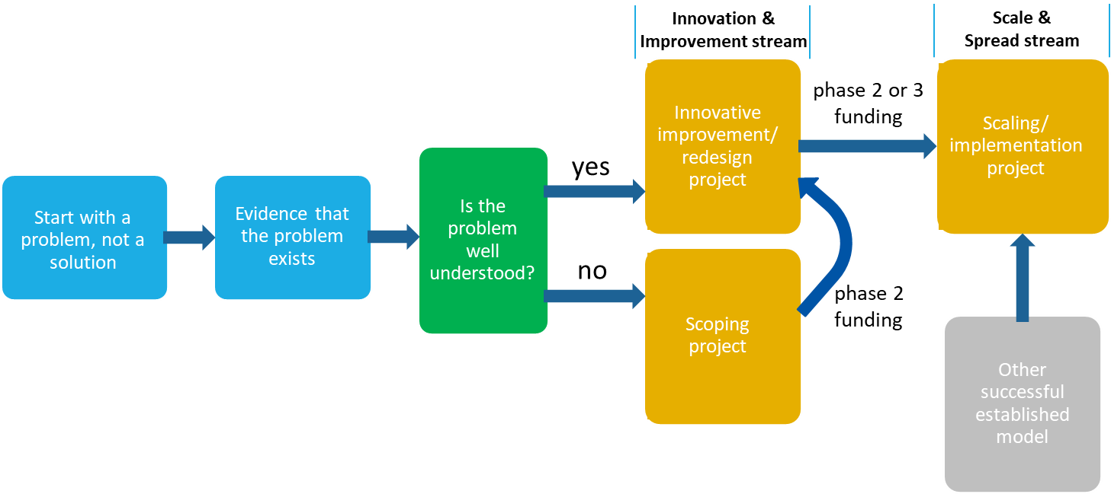
Figure 1: WCMICS Hybrid Grants Program Model

As shown in Figure 1, there is capacity for the Innovation & Improvement stream to include scoping projects where a problem is not well understood. Such projects can then go on to inform an improvement project in a second phase of funding. Innovation & Improvement stream projects can also go on to receive second phase funding from the Upscale & Spread stream if there is an opportunity to spread a successful project to other tumour streams or health services. The potential to upscale a project should be considered early in the planning stages so that phase 2 funding arrangements can be planned to maintain project momentum.
* The funding guidelines in this document apply only to the Innovation & Improvement stream.

VICS Implementation Plan 2021-24
The VICS Implementation Plan summarises how, over the next few years, the VICS will work towards addressing its roles and responsibilities in the Victorian Cancer Plan 2020-2024 (VCP). Figure 2 shows the three core priorities of the plan and specific action areas that sit under those priorities.

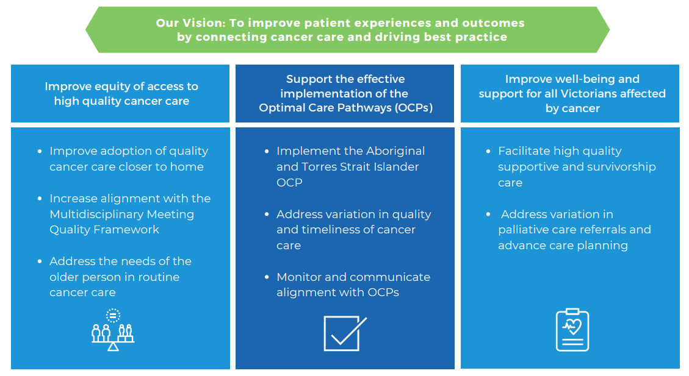
Figure 2: VICS Priorities

2022-23 WCMICS funding priority area

This year, the WCMICS Improve and Innovate funding stream is focused on enhancements or innovations that support the safe, quality delivery of virtual and remote models of cancer care and/or services.

This may include, but is not limited to:
- Remote patient monitoring programs, including equipment purchase.
- Expansion of rapid access remote services, e.g. Expanding Symptom Urgent Review Clinics (SURC) to include remote assessment for a wider range of patients such as palliative care, surgical, radiotherapy.
- Establishing virtual patient navigators to guide patients through remote care options.
- Remote collaboration with primary care providers to facilitate telehealth, including enabling clinical examination and remote prescribing.
- Transitioning existing programs to online delivery, e.g. prehab/rehab programs, patient education sessions, virtual ED, virtual clinical pharmacy service, smoking cessation programs.
- Optimisation of patient information materials for online delivery, including translation into languages other than English. This may also include patient feedback/experience mechanisms.

The above list are suggestions only and all other ideas that fit into the overarching virtual/remote care theme will be considered. This may include projects addressing home-based care models such as Hospital in the Home, but work in this area must align with the Better at Home program funded through the Health Service Partnerships. WCMICS staff are available to discuss project ideas and applicants are encouraged to get in contact before they finalise their expression of interest. (michael.barton@petermac.org | 03 8559 9062)

Funding Availability

Applications for funds are open to individual health services or multiple health services (with a lead health service clearly designated) to support the implementation of innovative improvement/redesign projects, which are within the remit of the ICS and address the focus areas listed above.

Funding allocation will be determined by the overall pool of applications. Applications must address criteria, as set out in these guidelines, to successfully attain funding.

Application Process & Project Evaluation

Expressions of Interest (EOIs) should be completed using the attached EOI template. All EOIs must be submitted to WCMICS via the health service’s nominated representatives as listed in Table 2 below. There is no limit on the number of EOIs that a health service can submit but health services are required to rank their submitted EOIs in order of alignment with local organisational priorities. This ranking will be used by WCMICS to shortlist EOIs in the event that there is not capacity to evaluate all EOIs at the project pitch session.

Health Service | Nominated representatives
Health Service | Clinical / operations lead | Executive lead
Melbourne Health | Kristie Mackenzie – Director Nursing and Operations Manager, Medical Services  Kristie.Mackenzie@mh.org.au | 0413 563 593 | A/Professor Kirsty Buising – Medical Director, Medical Services  Kirsty.buising@mh.org.au
Peter MacCallum Cancer Centre | A/Prof Kate Burbury - Consultant Haematologist, Director, Digital and Healthcare Innovations  kate.burbury@petermac.org | 03 8559 8425 | Geraldine McDonald - Director of Prevention and Wellbeing  Geraldine.McDonald@petermac.org | 03 8559 6265
Royal Victorian Eye & Ear Hospital | Jane Poxon – Executive Director of Operations/ Chief Nurse  JANE.POXON@eyeandear.org.au
Royal Women’s Hospital | Dr Mark Garwood - Chief Medical Officer  mark.garwood@thewomens.org.au | Laura Bignell - Executive Director Nursing and Midwifery and Neonatal Director  Laura.Bignell@thewomens.org.au
St Vincent’s Hospital Melbourne | Lesa Stewart - Group Manager Cancer and Palliative Care Services  Lesa.STEWART@svha.org.au | 03 9231 4818 | Jane Taylor - General Manager Specialty Services  Jane.TAYLOR@svha.org.au | 03 9231 4739
Werribee Mercy Hospital | A/Prof Thomas Chan - Clinical Services Director Medical, Subacute and Palliative Care Services. Thomas.Chan@mercy.com.au | Edward Wallace - Program Director Perioperative and Specialist Services EWallace@mercy.com.au
Western Health  (including Djerriwarrh Health) | Dr Dishan Herath - Director of Cancer Services  Dishan.Herath@mh.org.au | 0417 058 829 | Anthony O’Donnell - Divisional Director, Division of Aged, Cancer and Continuing Care Anthony.O’Donnell@wh.org.au | 0429 143 327
Table 2: Health Service nominated representatives for WCMICS Grants Program expressions of interest

It is strongly recommended that applicants speak to their local nominated representatives before completing the EOI template to ensure their project idea is aligned with local priorities. (See Table 2 for contact details.) WCMICS staff are also available to discuss project ideas and applicants are encouraged to get in contact before they finalise their EOI. (michael.barton@petermac.org | 03 8559 9062)

Applications that are submitted by the applicants directly to WCMICS and not through the nominated health service representatives will be deemed ineligible for funding.

Multi-site projects are encouraged, where appropriate, and should be submitted with an identified lead health service. WCMICS staff or the above health service contacts can be utilised to connect applicants with their appropriate counterparts at other health services. This applies to health services outside of the WCMICS region, where WCMICS staff can link in with colleagues from other regions to explore potential partnerships.

All Expressions of Interest for the WCMICS Grants Program Innovation and Improvement stream 2022-23 must be received by the WCMICS Directorate by 5.00pm on 25 October 2022. Please submit applications via email to contactwcmics@petermac.org .

Consumer Input

Engagement of consumers is a core element of the WCMICS Grants Program, with all funded projects encouraged to include people with experience of cancer on their steering group. The WCMICS Consumer Group review all EOIs and their feedback is represented by consumer members on the evaluation panel.

An independent evaluation of the Grants Program recommended that WCMICS should further strengthen the involvement of consumers and members of the WCMICS Consumer Group have expressed a preference to be engaged at an earlier stage in the process. To facilitate this the EOI template now includes a “Voice of Consumer” section where applicants can demonstrate that they have consulted with at least one consumer in the development of their project idea. If a consumer cannot be sourced internally through the health service applicants can contact WCMICS to request that a member of the WCMICS Consumer Group gets in touch to discuss their EOI.

If successful in receiving funding there is then an opportunity for the relationship between the consumer(s) and the project to continue into the planning stage and throughout the duration of the project.

Evaluation Panel and Project Endorsement

An initial screening of EOIs against the general criteria will be performed by the WCMICS directorate. Dependent on the number of EOIs making this initial shortlist, further shortlisting may occur based on the priority ranking provided by the health services. Applicants with shortlisted EOIs will be invited to pitch their projects in front of an evaluation panel in the week beginning 14 November 2022.

The evaluation panel is made up of members (including consumers) of the WCMICS Governance Committee, WCMICS Clinical Management Advisory Committee, WCMICS directorate leadership and Department of Health representatives. They will evaluate the projects based on technical merit, potential impact, sustainability, scalability and value for money.

The panel recommend which projects should be put forward for funding endorsement by the WCMICS Governance Committee. Project applicants will be advised of the outcomes of the Evaluation Panel project pitch session via email on or before 2 December 2022. The list of successful EOIs will also be published on the WCMICS website www.vics.org.au/wcmics .

Following endorsement WCMICS staff will be available to work with successful EOI applicants and consumers to help finalise project paperwork prior to disbursement of funds around February/March 2023.

Funding Timetable and Process Flowchart

Timetable for Application Process
ACTION | DATE
Call for Expressions of Interest (EOI) | 14 September 2022
EOI close | 25 October 2022
Invitations sent to pitch EOI to Evaluation Panel | By 28 October 2022
EOI Evaluation Panel Pitch Session | By 18 November 2022
Endorsement by WCMICS Governance Committee | 29 November 2022
Applicants informed of outcome | By 2 December 2022
Formal announcement of funded projects | By 2 December 2022
Funding commencement | February/March 2023
Project completion | By mid-2024

Process Flowchart
5. EOI applicants make live pitch to Evaluation Panel
(Week beginning 14 November 2022)
1. Funding Guidelines published
(14 September 2022)
2. EOI preparation including voice of consumer and local endorsement / prioritisation by health services.
3. Prioritised EOIs submitted to WCMICS by nominated representative at each health service.
(By 25 October 2022)
4. EOIs assessed by WCMICS against general selection criteria
EOI not progressed – does not meet general selection criteria (Notified by 28 October 2022)
EOI progressed – invited to panel pitch session (Notified by 28 October 2022)
6. Evaluation Panel shortlist successful project pitches (Immediately following Q&A session)
7. Shortlisted projects presented to Governance Committee for endorsement (29 November 2022).
Applicants notified by 2 December 2022
9. Funding allocated and project commenced (February/March 2023)

WCMICS Consumer Group review all EOIs

EOI not progressed – Not shortlisted by Evaluation Panel (Notified by 25 November 2022)

8. Project plans finalised with WCMICS assistance.
(December 2022 to January 2023)

Selection Criteria for WCMICS Grants Program Innovation and Improvement Stream 2022-23

All project applications will be evaluated for compliance with the WCMICS Funding Guidelines 2022-23 and screened using the selection criteria outlined below:

General Inclusion Criteria
- the duration of the project (or project phase for multi-phase projects) must be no longer than 18 months
- projects must aim to improve care and/or experience for people affected by cancer through innovation /redesign of current services (Projects aiming to implement a service improvement successfully piloted elsewhere would be suitable for the Scale & Spread stream of the grants program)
- projects must aim to implement a sustainable improvement in service provision
- EOIs must nominate a WCMICS health service as the lead organisation but projects may involve multiple health services and / or other organisations such as peak bodies, academic health science centres, charities and not-for-profit organisations
- projects must fit with the organisational objectives for the relevant clinical area
- projects must reference the relevant WCMICS priority area being addressed
- if the purpose of the project is to demonstrate a need for an ongoing service change and is gathering evidence to build a business case, the application must receive explicit support from the organisation/s to continue to fund the service change, if it meets agreed organisational criteria (this will be required at the Project Plan stage to meet this criterion)

General Exclusion Criteria
- projects that fail to address the general selection criteria
- recurrent positions or non-sustainable initiatives – specifically noting the criteria to support building a business case (outlined under inclusion criteria above)
- the provision of staff to provide direct patient care
- the provision of staff to provide data entry or data managers
- corporate overhead fees
- projects submitted directly to WCMICS by individual applicants (i.e. projects must go through health service prioritisation and be submitted by relevant nominated representative)
- projects which are inconsistent with the objectives of WCMICS and/or other state-wide initiatives
- production of intellectual property that is then held by a third party e.g. Software development companies

Conditions of Funding & Reporting Requirements

Funding will be allocated to successful applicants on the basis that:
- The project has been approved for funding by the evaluation panel as described above with any specific conditions specified by the review panel having been met in the project plan documents.
- The project will be conducted in accordance with the methodology, timelines and allocated budget stated within the final agreed project plan and the conditions stipulated in these guidelines. Any deviation in the project from the original submission must be discussed with and agreed to by the WCMICS Directorate and documented in a Project Amendment Form supplied by WCMICS.
- Ethics applications (where necessary) are submitted by the Project Lead in line with local health service requirements.
- Quarterly project updates will be provided by the Project Lead and report through to WCMICS Clinical Management Advisory Committee and Governance Committee. Updates will include a brief synopsis of work completed in the previous three months, highlight any achieved objectives, identify risks both new and mitigated, and identify key project deliverables met as appropriate. Quarterly reports will be presented at WCMICS Governance Committee meetings.
- Project Leads be available to participate in WCMICS funded projects Communities of Practice
- An Interim Progress Report and Final Report (including evaluation, sustainability and expenditure report) will be submitted to the WCMICS Directorate at the project mid-point and completion, respectively (templates to be provided by WCMICS).
- Failure to supply project Interim and Final reports may affect future funding applications for that health service.
- Information on the project, including any tools/resources developed, will be made available to the WCMICS Directorate to enable promotion of the Grants Program and information sharing with other organisations.
- WCMICS is to be acknowledged as the funding body in any published documents, or during any presentation of the project outcomes or associated results of process improvements. Failure to acknowledge WCMICS may affect future funding applications.

Funds Release Notification

Project funding will be awarded to successful applicants and made available to the hospital/health service with an initial invoice to be raised upon notification from WCMICS.

Further Information

Please note that advice about previous successful WCMICS projects is located in Appendix 1 and on our Improvement Hub website: cancerserviceimprovementhub.com . For further information on the WCMICS Grants Program, including advice on the suitability of projects for submission, please contact Michael Barton (WCMICS Deputy Manager) on 03 8559 9062 or michael.barton@petermac.org .

Key Resources

Optimal Care Pathways
http://www.cancervic.org.au/for-health-professionals/optimal-care-pathways
Victorian Cancer Plan
https://www2.health.vic.gov.au/about/health-strategies/cancer-care/victorian-cancer-plan

WCMICS Improvement Hub
www.cancerserviceimprovementhub.com

Appendix 1:

Elements that make a successful WCMICS-funded project

Common elements of successful projects WCMICS has funded to date are:
- The project addresses a recognised need within the organisation or network and has senior management/clinician support. Transferability to other health services has also been considered.
- Relevant stakeholders (including other sites) are involved before project initiation and frequently engaged throughout the life of the project.
- There is a clear vision of what the project is trying to achieve, the approach that needs to be taken and how success will be proven.
- A formal project methodology is used and followed, with clear milestones and measures employed.
- A clear governance structure is in place headed by a steering committee with WCMICS involvement.
- Realistic budget and achievable timelines are set and adhered to. The scope of the project is tightly managed, with any amendments discussed and agreed upon with WCMICS prior to progressing.
- The right resources are secured and retained. WCMICS resources and staff are utilised for their ‘know-how’ throughout the life of the project.
- Consumers are engaged throughout the life of the project.
- Clear communications are made about priorities and expectations (including participation requirements).
- A network of project champions is established and utilised.
- Datasets are agreed upon early and routinely collected and analysed throughout the life of the project. Attention is given to what data is needed to build internal business cases to enable sustainability where applicable.
- The results and knowledge gained are well documented, presented and shared (and hopefully published). The final report should include the challenges and obstacles to success (or failure) can be captured and shared.

Appendix 2:

Expression of Interest template

Grants Program 2022/23
Expression of Interest (EOI) for the Innovation & Improvement funding stream
Instructions for Submission:
Speak to your nominated local representative (see Table 2 in attached funding guidelines) before completing this template to ensure your idea will fit with local priorities. All EOIs must be submitted via the nominated health service representatives.
Advice can be sought from Michael Barton (Quality & Performance Manager) on 03 8559 9062 or michael.barton@petermac.org

EOIs are due for submission to WCMICS by 5.00pm on 25 October 2022 via contactWCMICS@petermac.org
Project title: (Max. 25 words)

Please list health services to be included in this project:
☐ | Melbourne Health | ☐ | Royal Women’s Hospital
☐ | Peter MacCallum Cancer Centre | ☐ | St Vincent’s Hospital Melbourne
☐ | Royal Victorian Eye & Ear Hospital | ☐ | Werribee Mercy Hospital
☐ | Western Health (including Djerriwarrh Health Services)
☐ | Additional organisations:

Please list tumour stream(s) to be included in this project:
☐ | Breast | ☐ | Central Nervous System
☐ | Colorectal | ☐ | Endocrine/Thyroid
☐ | Genitourinary | ☐ | Gynaecology
☐ | Haematology | ☐ | Head & Neck
☐ | Lung | ☐ | Skin/Melanoma
☐ | Upper GI | ☐ | All

2022-23 WCMICS funding priority area
This year, the WCMICS Improve and Innovate funding stream is focused on enhancements or innovations that support the safe, quality delivery of virtual models of cancer care and/or services. See attached funding guidelines for more details.

Project Details
Please stay within the set word limits. Applicants will have the opportunity to further explain their project ideas in person at an evaluation panel pitch session to be held after submission.

Problem statement – what issue will the project address? (Max. 75 words)

Brief project summary: (Max. 500 words)

Voice of consumer (Max. 250 words)
Applicants should demonstrate that they have consulted with consumers in the development of this EOI. If consumers cannot be sourced internally through the health service or other sources, applicants can contact WCMICS to request that a member of the WCMICS Consumer Group gets in touch to discuss their EOI.
Please include direct and specific quotes from people affected by cancer regarding:
- Whether the project will bring benefits that are important to patients and carers.
- Any potential unwanted negative effects on patient care or experience.
- How consumers could be involved in the project, including in the planning phase.
In some cases consumers may be comfortable to complete this section themselves.

Briefly describe on-going sustainability of project deliverables post-funding (Max.100 words)
Optional - Links to external references to support your proposal. (Max. 1000 characters)

Total Funding Requested (incl. GST)  (Breakdown of expenditure can be included here if known) | $

Endorsements
Applicant declaration:
I certify that the information in this Expression of Interest is accurate and has been compiled in accordance with the WCMICS Grants Program Innovation & Improvement Stream Guidelines 2022/23. The EOI has been discussed with relevant stakeholders, including my line manager, consumers and any listed partner organisations.
Name:
Position: | Email:
Signature: | Date:
Nominated Clinical/Operational representative declaration:
I certify that this Expression Of Interest has organisational support and has been prioritised internally by this health service for the WCMICS Grants Program Innovation & Improvement Stream 2022/23.
Name:
Position:
Signature: | Date:
Nominated Executive representative declaration:
I certify that this Expression Of Interest has organisational support and has been prioritised internally by this health service for the WCMICS Grants Program Innovation & Improvement Stream 2022/23.
Name:
Position:
Signature: | Date:

Health service internal prioritisation rank:

Partner organisation declaration: [Optional. Attach additional sheets if more than one partner organisation engaged.]
I fully support my organisation’s involvement in this potential project
Name:
Position:
Organisation:
Signature: | Date:

